**Nalaiya Thiran (IBM)**

**ASSIGNMENT – 1**

**Make a Smart Home in Tinker cad, using 2+ sensors, Led, Buzzer in single code and circuit.**

**Smart Home Automation Tinker cad link:** [**https://www.tinkercad.com/things/kHnSnbxf7jL-smart-home-automation/editel?sharecode=B2TZ69QbnEjuOeTzwXKoCxbndNRlITUX6vW_o4GTDNA**](https://www.tinkercad.com/things/kHnSnbxf7jL-smart-home-automation/editel?sharecode=B2TZ69QbnEjuOeTzwXKoCxbndNRlITUX6vW_o4GTDNA)

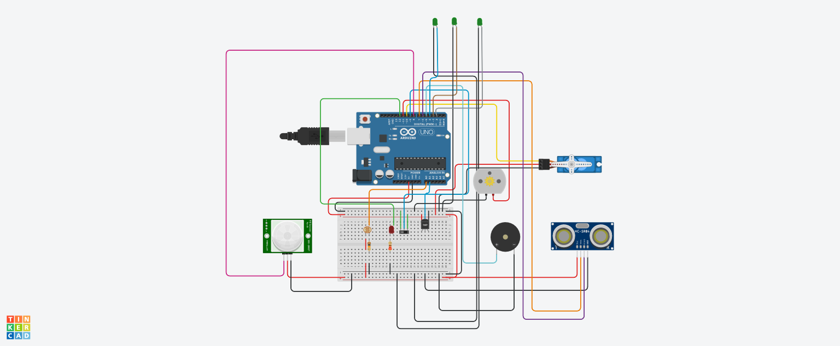

**Program Code:**

#include <Servo.h>

const int PIR_Sensor = 8;

Servo doorservo;

int ldr = A0;

int led = 12;

int tmp = A1;

int motor = 11;

int d;

int const trigPin = 7;

int const echoPin = 6;

int const buzzPin = 5;

void setup()

{

pinMode(ldr,INPUT);

pinMode(led,OUTPUT);

pinMode(tmp,INPUT);

pinMode(motor,OUTPUT);

doorservo.attach(10);

pinMode(trigPin, OUTPUT);

pinMode(echoPin, INPUT);

pinMode(buzzPin, OUTPUT);

pinMode(2, OUTPUT);

pinMode(3, OUTPUT);

pinMode(4, OUTPUT);

pinMode(9,INPUT);

}

void loop()

{

int ldrs = analogRead(ldr);

if(ldrs <= 300)

{

digitalWrite(led,HIGH);

digitalWrite(2,HIGH);

digitalWrite(3,HIGH);

digitalWrite(4,HIGH);

}

else

{

digitalWrite(led,LOW);

digitalWrite(2,LOW);

digitalWrite(3,LOW);

digitalWrite(4,LOW);

}

int reading = analogRead(tmp);

float voltage = reading * 5.0;

voltage /= 1024.0;

float temperatureC = (voltage - 0.5) * 100 ;

if(temperatureC >= 30)

{

digitalWrite(motor,HIGH);

}

else

{

digitalWrite(motor,LOW);

}

d = digitalRead(9);

if(d== 1){

doorservo.write(100);

}

else{

doorservo.write(0);

}

int duration, distance;

digitalWrite(trigPin, HIGH);

delay(1);

digitalWrite(trigPin, LOW);

duration = pulseIn(echoPin, HIGH);

distance = (duration/2) / 29.1;

if (distance <= 50 && distance >= 0) {

digitalWrite(buzzPin, HIGH);

} else {

digitalWrite(buzzPin, LOW);

}

delay(60);

if (digitalRead(PIR_Sensor)==HIGH)

{digitalWrite(buzzPin, HIGH);}

else {digitalWrite(buzzPin, LOW);}

}